**Leader Overview**

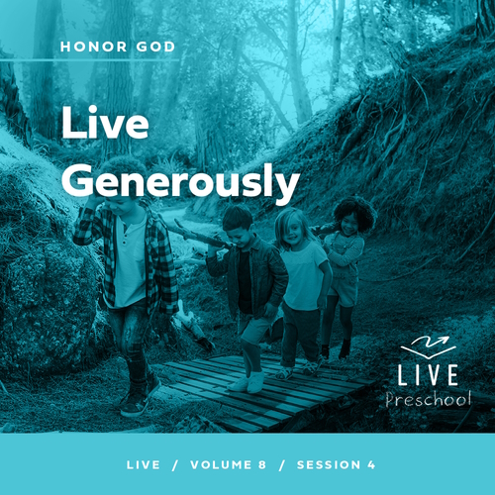

**Volume Overview**

**Honor God**

*Most people think of worship as exclusively songs and music. We think worship is something we do in a service on Sunday mornings. But the Bible calls us to give our entire life as worship. We honor God with our songs and praise, but all of life is an opportunity to show God honor. We worship best when we make it a lifestyle, expressing our gratitude, prioritizing our time with Him, purifying our heart and actions, and generously sharing with others. We worship as we honor God with our whole life.*

**Session Overview**

**Live Generously**

*In this* **Live** *session, preschoolers will hear the parable Jesus told about three workers who managed their master’s money. Two managed it with wisdom while one hid his money in the ground. Preschoolers will explore the truth that God gives them gifts that they should share with others.*

**Bible Lesson**

Parable of the Talents

[Matthew 25:14–30](https://ref.ly/logosref/Bible.Mt25.14-30)

**Faith Fact**

I will use my gifts for God.

**Faith Verse**

[Psalm 86:12](https://ref.ly/logosref/Bible.Ps86.12) (NLT)

With all my heart I will praise you, O Lord my God. I will give glory to your name forever.

**Preparing for the Session**

**Leader Preparation Time: 20–25 Minutes**

|  |
| --- |
| ***You Will Need***  ***Preservice Activities***  *• Toys*  *• Gift bag with tissue paper*  *• Cookies*  *• Napkins*  ***Large Group***  *• Bible*  *• Worship songs (Song suggestions: “Your Love For Me” Lyric Video by North Point Kids; “Graves into Gardens” Lyric Video by Elevation Church Kids; “Spirit Move” Lyric Video by Bright Ones)*  *• For groups not using a phone or tablet only, add:*  *• Projector or TV*  *• Laptop*  *•* ***Faith Fact Sound*** *video (bell ringing)*  *•* ***Faith Fact Slide***  *•* ***Faith Verse Slide***  *•* ***Faith Verse Video***  *•* ***Bible Lesson Video A***  *•* ***Bible Lesson Video B***  ***Small Group***  *•* ***Small Group Activity Page****, one per kid*  *• Pencils or pens, one per kid*  *• Crayons or markers*  *• Gift wrap paper, crumpled into twenty to thirty paper wads per team*  *• Floor-safe tape*  *• Music*  *• Device to play music*  *•* ***Small Group Hands-On Learning Page****, one per group*  *• Small heart stickers, one per kid*  *• Optional: Red marker*  *To access session content and videos from a computer, visit:* [***BibleEngagementProject.com/downloads***](https://bibleengagementproject.com/downloads) |
| ***Getting Ready***  ***Preservice Activities***  *• Set out toys and snacks.*  ***Large Group***  *• Download videos and slides if needed.*  *• Select worship song(s) and have them ready to play.*  ***Small Group***  *• Print copies of the* ***Small Group Activity Page****, one per kid.*  *• Place a strip of floor-safe tape down the center of the playing area to divide it in half for the game.*  *• Print the* ***Small Group Hands-On Learning Page,*** *one per group.*  ***First time leading* Live *for Preschool? Check out the*** [**Facilitator Guide**](https://0b769b0ed3569ef9d18b-f88d8272f61086866d50d048b43ef630.ssl.cf2.rackcdn.com/sites/biblengagementproject/Listen_Facilitator_Guide.pdf)**.** |

**Preservice Activities**

*See what’s needed at the beginning of the session.*

**Bible Story Warm-Up**

Who likes to get presents? *(Group response)* Me too! Getting gifts is awesome!

• *Hold up the gift bag.*

What are some reasons someone might give you a present?

What is the best gift someone has given you?

What is the best gift you have ever given someone?

Gifts can be a great thing to receive and to give. What would happen if we never opened the gifts we were given? Imagine if I gave you a present like this one *(point to gift),* and you never looked inside to see what the gift was. Would the gift go to waste? *(Group response)* In the Bible, Jesus taught about the importance of the gifts that God gives to us. He doesn’t want us to leave those gifts wrapped up and unused. I can’t wait to learn more about the gifts God has for us. It’s going to be a fun day of learning together with you.

• *Share about a favorite gift you received that kids could relate to. Also share who gave you the gift.*

**Snack**

**Cookies**

We’ll do something a little different for our snack today. When I bring the snacks to you, I want you to take one and then give it away. When it’s your turn, look for someone who doesn’t have a snack yet and share with them. We’ll do this until everyone has a snack.

• *Distribute the cookies and napkins.*

• *Let kids share them with others.*

Was it fun getting to give a snack to your friend?

Was it easy or hard to give someone their snack before you got yours?

The great thing about giving someone else their snack first is that you got to experience the joy of sharing. You also did it while knowing that you would get a snack, too. Today, we’ll learn that God has special gifts for each of us. What God has given us is a lot more special than these cookies, and He wants us to share it with others.

**Free Play**

*Any extra time can be spent playing with toys.*

**Transition**

*A few minutes before service begins have kids make their way to the large group area and sit in their designated areas.*

**Large Group**

**25 Minutes**

*See what’s needed at the beginning of the session.*

**Introduction**

Hi, friends! What a great day it is when we get to come here together! I love exploring God’s Word with you. *(Hold up the Bible.)* The Bible is a great book to read, and God wants to talk to us through His Word.

Today, we’ll hear a story Jesus used to teach us an amazing truth. Nod your head yes if you want to know what it is. *(Group response)* Oh, good! Here’s that truth. God made you very special. He gave special gifts to you because He loves you. We get to share those gifts with others. Isn’t that amazing? *(Group response)*

**Faith Fact**

Hey, that’s our Faith Fact today! **I will use my gifts for God.**

• *Show the* ***Faith Fact Slide.***

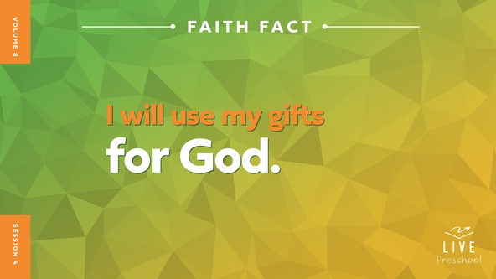

Let’s say our Faith Fact together. **I will use my gifts for God.** I want you to think about something you love to do—maybe that’s reading books, playing soccer, building with blocks, singing, or giving great hugs. Those are all gifts God has given you. While we say our Faith Fact again, let’s each act out something we love to do. **I will use my gifts for God.** *(Pause for kids to act out a gift.)* Seeing you act those out makes me smile really big because they’re wonderful gifts you can use for God. Let’s say our Faith Fact one more time together. **I will use my gifts for God.**

**Bible Time**

It’s time to hear the story Jesus told. Do you think Lizzy is ready for us? *(Group response)* Let’s call her name. *(Call out, “Lizzy.”)* Here she is!

• *Play* ***Bible Lesson Video A.***

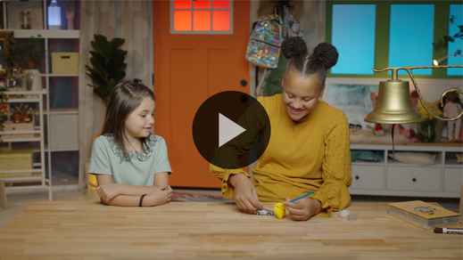

Grandpa and Lizzy gave us time to think, so let’s worship God. Then, we’ll come back and see what happens next in our Bible story.

**Worship**

God deserves our praise. He is so good, and He loves us so much! Let’s tell God how amazing He is.

**Praise**

Who wants to thank God for making you just the way you are? Crouch down low and then reach up to the sky. *(Group response)*

Are you glad God loves you? Clap as loud and fast as you can. *(Group response)*

Who wants to use their gifts for God? Shout, “I do!” *(Group response)*

**Sing**

Let’s use the voice God has given us to worship Him by singing now.

• *Lead the kids in singing one or two songs. See song suggestions at the beginning of the session.*

**Prayer**

What a beautiful sound to my ears to hear you singing praises to God! Let’s talk to Him now because He loves us so well.

|  |
| --- |
| *Dear God, You created us. You know us, and You love us. We praise You for that. We want to share Your love with the people around us. Amen.* |

**Bible Time cont’d**

It’s almost time for Grandpa and Lizzy to come back! Let’s think about what might have happened next in our Bible story. Put on your thinking cap *(demonstrate).* What do you think? Did the workers make wise decisions with the gifts they had been given and end up with even more? *(Point to “full bag of money” graphic.)* Or did they not make wise choices with their money? *(Point to “almost empty money bag” graphic.)* Let’s find out what happened next. Let’s check back in with Lizzy and Grandpa. Grandpa will ask you to pick an action to show your answer.

• *Play* ***Bible Lesson Video B.***

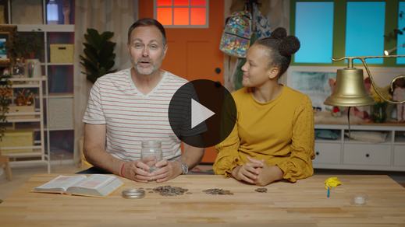

**Response Time**

*Play a worship song quietly.*

We’ve heard an important truth from the Bible, and we always want to respond to God’s Word. We have many good gifts that God has given us. Let’s extend our hands like we’re holding out our gifts to God *(demonstrate)* while we pray together.

• *Have the kids repeat phrases of the prayer after you.*

|  |
| --- |
| Dear God, thank You for creating me. Thank You for giving me gifts. I want to use them all for You. I want to share Your love with others. Amen. |

**Faith Verse**

One of the best gifts God has given you is a mind to learn. Let’s use that gift right now by saying our Faith Verse together.

[Psalm 86:12](https://ref.ly/logosref/Bible.Ps86.12) (NLT)

With all my heart I will praise you, O Lord my God. I will give glory to your name forever.

• *Show the* ***Faith Verse Video.***

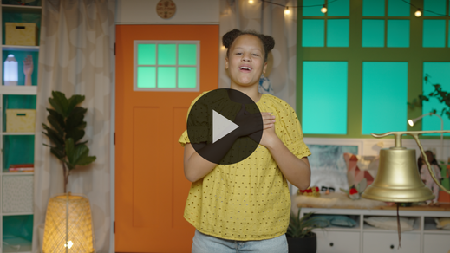

**Psalm** *(hands at waist, spread apart, palms up and out)*

**86:** *(hands together like a clap)*

**12** *(hands opened to “book”)*

**With all my heart** *(arms extended and bring in to cross over heart)*

**I will praise you,** *(lift hands and move side to side)*

**O Lord my God.** *(point and look to sky)*

**I will give glory to your name forever.** *(spin around)*

**Closing**

Give me a thumbs up if you’ve had a great time learning from Jesus with me. *(Group response)* I love exploring God’s truths with you. *(Give a thumbs up.)* We have worshipped God through singing, and we’ve said our Faith Verse. Is there anything else we need to do one more time?

• *Play the* ***Faith Fact Sound*** *video (bell ringing).*

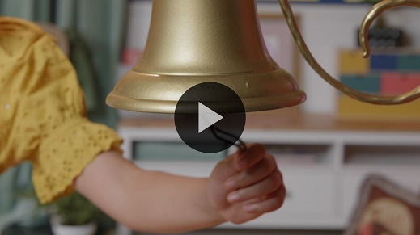

Oh, right! We need to say our Faith Fact again! **I will use my gifts for God**.

• *Show the* ***Faith Fact Slide.***



Let’s whisper it together first because we want to use our gifts for God even when we’re by ourself and no one else is around. **I will use my gifts for God.** Mostly we want to share our gifts from God with other people, so let’s say our Faith Fact as loudly as we can. **I will use my gifts for God**.

**Dismissal to Small Groups**

That sounded so great! Now, it’s time to do some really fun activities with your friends in your small group.

• *Dismiss the kids by groups.*

|  |
| --- |
| ***Leader Tip:*** *This can be done by assigning color teams or by age groups. Note that some young preschoolers may not know their age. Using a colored sticker, jersey, or wristband will help separate the kids and help identify their small groups.* |

**Small Group**

**25 Minutes**

*See supplies and prep instructions at beginning of session or in each activity below.*

|  |
| --- |
| ***Leader Tip:*** *Small groups can alternate to each circle, or all groups can do each activity at the same time. If you choose to alternate, you will need at least one leader per circle.* |

**Circle 1**

**Group Connection**

**Praise Charades**

|  |
| --- |
| *No supplies or prep are needed for this activity.* |

One of the best things that we can do is learn God’s Word. Let’s pause and say our Faith Verse together.

• *Lead kids through the Faith Verse and actions.*

[Psalm 86:12](https://ref.ly/logosref/Bible.Ps86.12) (NLT)

With all my heart I will praise you, O Lord my God. I will give glory to your name forever.

**Psalm** *(hands at waist, spread apart, palms up and out)*

**86:** *(hands together like a clap)*

**12** *(hands opened to “book”)*

**With all my heart** *(arms extended and bring in to cross over heart)*

**I will praise you,** *(lift hands and move side to side)*

**O Lord my God.** *(point and look to sky)*

**I will give glory to your name forever.** *(spin around)*

Awesome! This verse is about praising God. Sometimes when we praise God, we sing songs and play music. Did you know praising God is so much more than just the songs that we sing? *(Group response)* We praise God with how we live our life. We praise God when we listen to our parents and follow the rules. We praise God when we care for those who are hurting. There are so many ways that we can praise God.

I think we can come up with lots of ways that we can praise God wherever we go. We’ll go around the circle and each of you will show a way that you can praise God. When it’s your turn, you’ll jump up and show us one way to praise God. For example, you might choose to praise God by clapping your hands. What will you do when it is your turn? *(Group response)* If you wanted to praise God when you go to sleep at night, what might you do? *(Allow responses.)* Let’s give it a try.

• *Go around the circle and allow the kids to act out how they can praise God.*

• *Ask them for clues if needed for the group to guess.*

• *Whisper ideas to them as needed.*

Those were some really great examples of praising God! You gave me some good ideas! Why don’t we say our Faith Verse together one more time before we finish up. Ready?

• *Lead the kids through the Faith Verse and actions.*

**Circle 2**

**Activity Page Time**

**My Gifts**

|  |
| --- |
| ***You Will Need***  *•* ***Small Group Activity Page****, one per kid*  *• Pencils or pen, one per kid*  *• Crayons or markers*  ***Getting Ready***  *• Print copies of the* ***Small Group Activity Page****, one per kid.* |

In our Bible story, we learned that God has given us gifts. On your Activity Page, you will see examples of some of the things you might be really good at or enjoy doing. That’s one way to find the gifts God has given you.

• *Hand out a copy of the* ***Small Group Activity Page****, a pencil, and crayons to each kid.*

First, let’s look at these pictures together. If you think the picture shows something God has made you good at, mark in the box under the picture. Remember that in our Bible story, the people didn’t get the same number of gifts. You might have just one or two of these pictures marked when we’re done. That’s okay! Let’s talk about the pictures so that you can think about which of these gifts God has given to you.

• *Read and talk about the pictures.*

Remember our Bible story. Does God want us to hide our gifts or keep them a secret? *(Group response)* Let’s take turns sharing with the group about one of the pictures you marked. Then, tell us why you picked it.

• *Let each kid share if they are willing. Affirm each one who shares.*

I’m glad you know that God made you very special! He loves you very much. How many of you want to use the gifts God gave you to show others how much you love Him? *(Group response)* I do, too!

**Circle 3**

**Feet-to-Floor Game Time**

**Gift Share**

|  |
| --- |
| ***You Will Need***  *• Gift wrap paper, crumpled into twenty to thirty paper wads per team*  *• Floor-safe tape*  *• Music*  *• Device to play music*  ***Getting Ready***  *• Place a strip of floor-safe tape down the center of the playing area to divide it in half for the game.* |

In our Bible story, who did the boss praise—the worker who buried his money it in the ground or the workers who earned even more money? *(Allow responses.)* God doesn’t want us to hide our gifts either. He wants us to use them and share them with others. Would you like to play a game about that? *(Group response)*

• *Pour the wrapping paper balls in the playing space with half on each side of the taped line.*

These balls of paper represent our gifts. We’ll make two teams. When I say, “Go,” your team will work together to toss as many of these balls to the other team’s side as you can until the music stops. When the music stops, we’ll see which team did the best job of sharing their paper balls. The team with fewer balls of paper on their side is the winner. Who’s ready to play? *(Group response)*

• *Divide the group into two teams. Start the music to begin the game.*

• *Stop the music to end the round and determine which team has fewer paper wads.*

• *Play this game for as many rounds as time permits.*

• *After each round, practice the Faith Fact:* **I will use my gifts for God.**

• *Play the* ***Faith Fact Sound*** *video****.*** *Review the Faith Fact even if you can’t play the sound.*



Wow! You kids are great at sharing! Now, let’s see how fast you can help us pick up everything. Ready? Go!

• *Encourage the kids to pick everything up as quickly as possible.*

That was amazing! You definitely used your gifts to spread joy to me today.

**Circle 4**

**Hands-On Learning**

**Share God’s Love around the World**

|  |
| --- |
| ***You Will Need***  *•* ***Small Group Hands-On Learning Page****, one per group*  *• Small heart stickers, one per kid*  *• Optional: Red marker*  ***Getting Ready***  *• Print the* ***Small Group Hands-On Learning Page****, one per group.* |

The more time we spend learning about God, the more we discover how much He loves and knows us. Remember our Bible story? Jesus told that story to remind us that God has given each of us special gifts. He didn’t create any of us exactly the same, so no two people have the exact same gifts.

• *Show the* ***Small Group Hands-On Learning Page*** *to the group.*

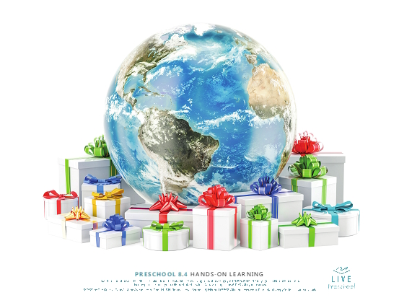

What do you see in the picture? *(Allow responses.)* Do you think God loves everyone in the whole world? *(Group response)* Yes, He does! God wants you and me to share His love. To do that, He wants you to use your gifts for Him. That’s exactly what our Faith Fact is about today. Can you help me say it? **I will use my gifts for God.**

Let’s pretend the gifts in this picture represent each of us. Look closely at them. Are they all the same? *(Group response)* Yes, they’re all gifts, but some are tall, and some are small. Their bows are different colors. God created us all different. Maybe God gave you a gift of singing or drawing. Maybe He made you great at running fast or cooking. Some of you are really good at making new friends and helping people.

No matter what God made you great at, you can use it to share His love. For example, we can use our gifts to show care for people who are sad or hurting. If you’re good at drawing, you could create a card to cheer them up. If God has given you a love of cooking, what could you do to show them God’s love? *(Allow responses.)* There are so many different ways that we can use our gifts to help others.

Here’s what we’ll do to show God we’re willing to use our gifts for Him. I want you to take turns and place your sticker on one of the gifts in the picture. When you place your sticker on the gift, I want you to tell us one of the special gifts that God has given you and how you can us it to share His love with others. I’ll go first.

• *Add your sticker and share how you will use your gift to share God’s love.*

• *Allow kids to place a sticker on the picture one at a time and share with the group.*

• *If they’re stuck, help them by pointing out a gift you see in them.*

• *Celebrate each gift shared with the entire group.*

It’s amazing how God handpicked special gifts for each one of us! Every gift that we have is from God. Amazing things happen when we give those gifts back to God.

**Dismissal**

• *Play the* ***Faith Fact Sound*** *video (bell ringing).*



• *Show the* ***Faith Fact Slide.***



Let’s say the Faith Fact together one last time before we go. **I will use my gifts for God.** I can’t believe our time together is almost over. I’ve had so much fun learning with you. It’s always such a great time when we get to discover more about God from His Word. I can’t wait to do that with you again soon. See you next time!

• *Send home the* ***Small Group Activity Page*** *with each kid.*

• *Remind parents that there are* ***Family Devotions*** *available on the app to do with their kid.*

• *Tell everyone the date and time for the next session.*

.